ITSE 1302

Travis Doporto

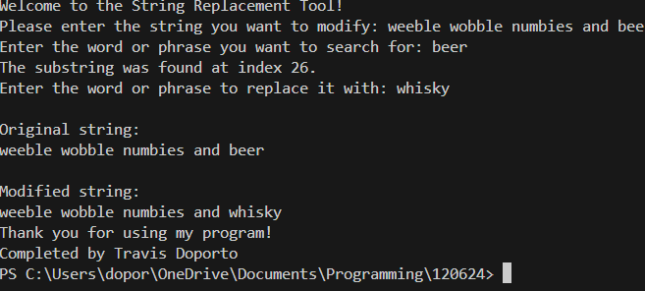

def get_string():

    user_input = input("Enter the string to search through: ")

    return user_input

def find_substring(main_string, sub_string):

    index = main_string.find(sub_string)

    if index != -1:

        print(f"The substring was found at index {index}.")

    else:

        print("The substring was not found.")

    return index

def userChoice():

    while True:

        choice = input(f"Do you want to replace this substring (y/n)?" ).strip().lower

        if choice == "y":

            return modified_string

        elif choice == "n":

            break

        else:

            print("Invalid input. Please enter (y/n).")

def completedBy():

    print("Completed by Travis Doporto")

def thanks():

    print("Thank you for using my program!")

def main():

    print("Welcome to the String Replacement Tool!")

    main_string = input("Please enter the string you want to modify: ")

    sub_string = input("Enter the word or phrase you want to search for: ")

    index = find_substring(main_string, sub_string)

    if index != -1:

        replacement = input("Enter the word or phrase to replace it with: ")

        modified_string = main_string.replace(sub_string, replacement)

        print("\nOriginal string:")

        print(main_string)

        print("\nModified string:")

        print(modified_string)

    else:

        print("\nNo replacement was made as the substring was not found.")

    thanks()

    completedBy()

if __name__ == "__main__":

    main()